# CS 255 System Design Document

Josh Hall

## UML Diagrams

### UML Use Case Diagram

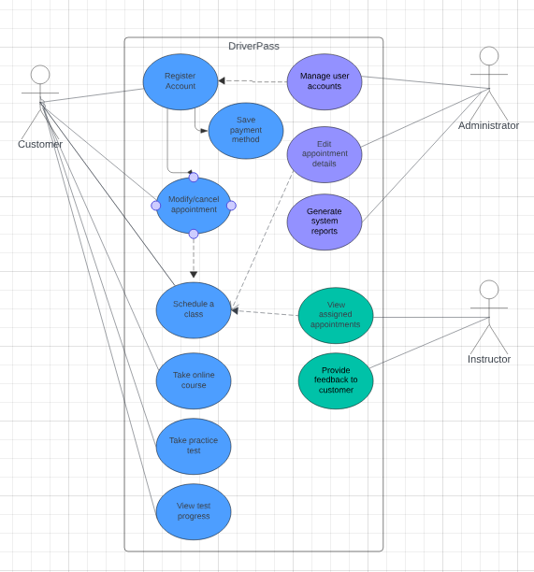

### UML Activity Diagrams

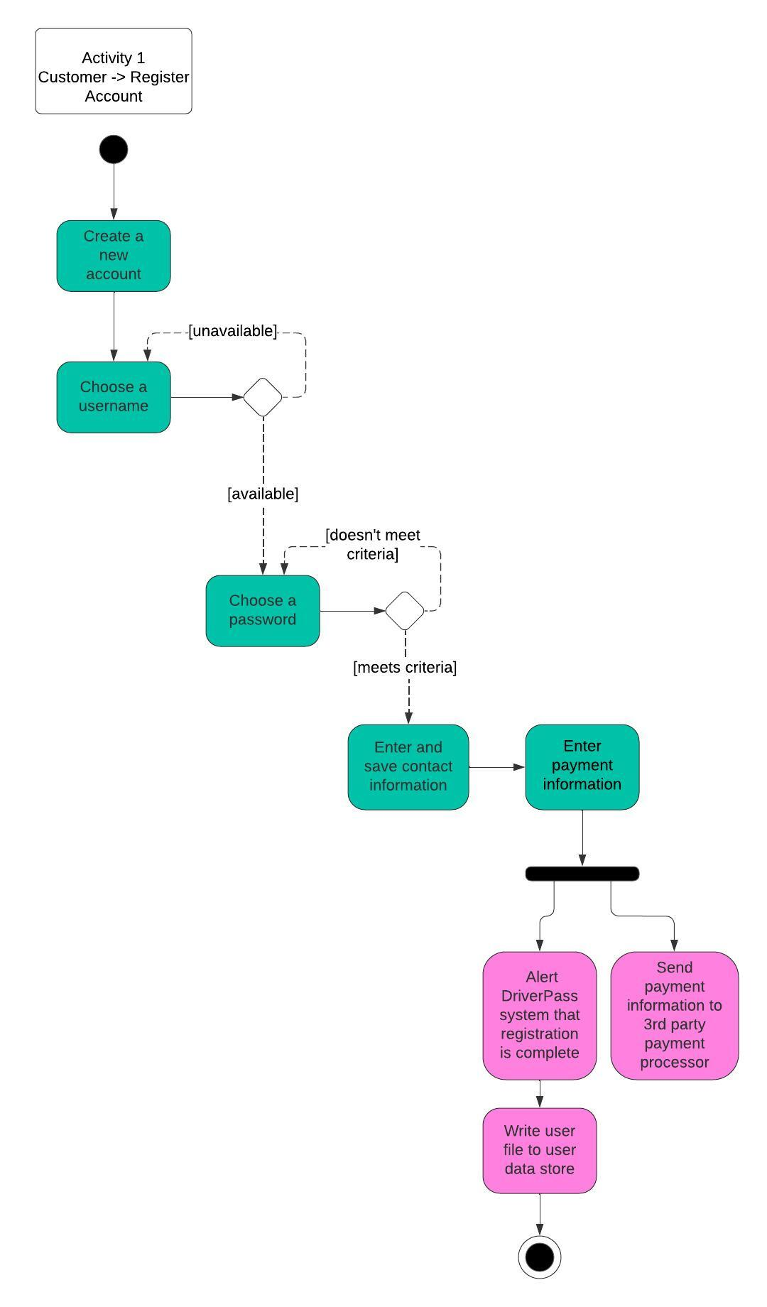

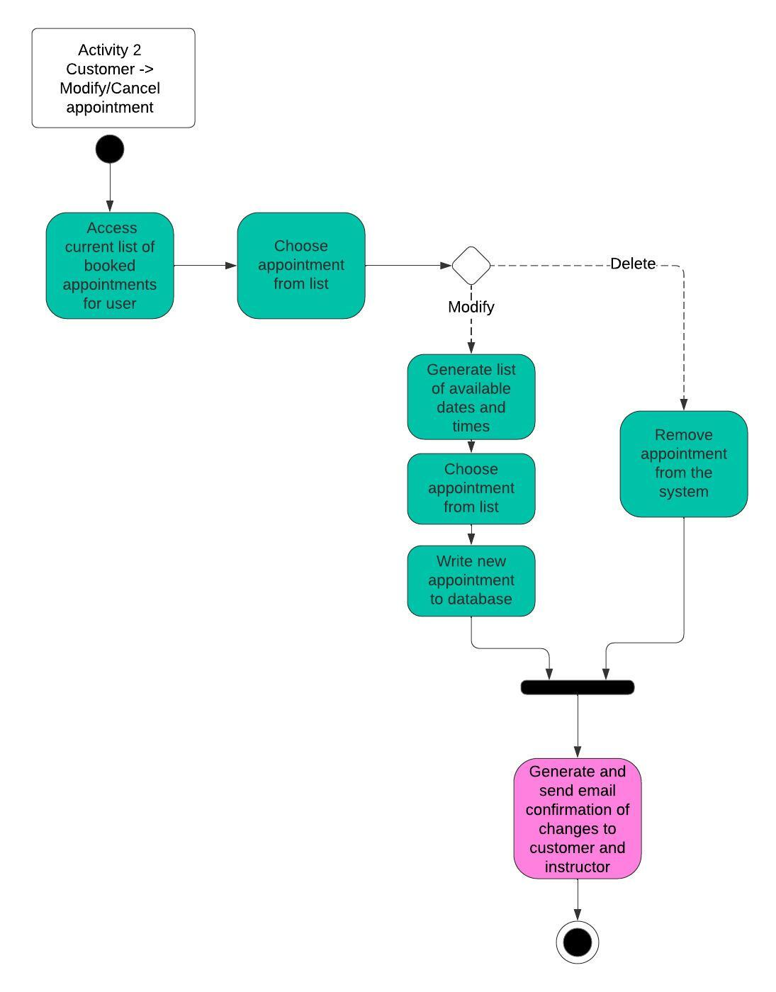

### UML Sequence Diagram

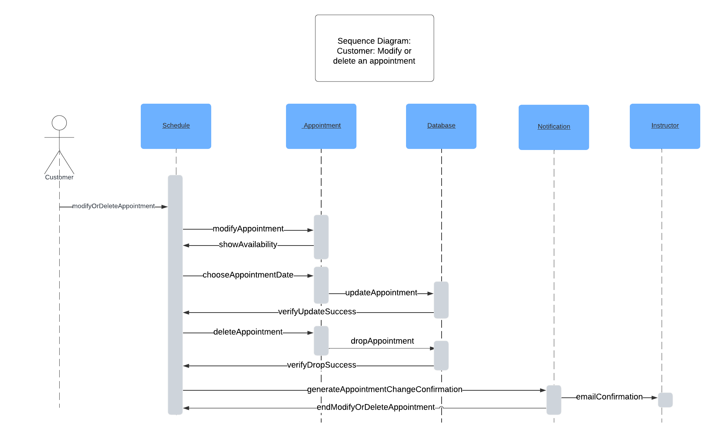

### UML Class Diagram

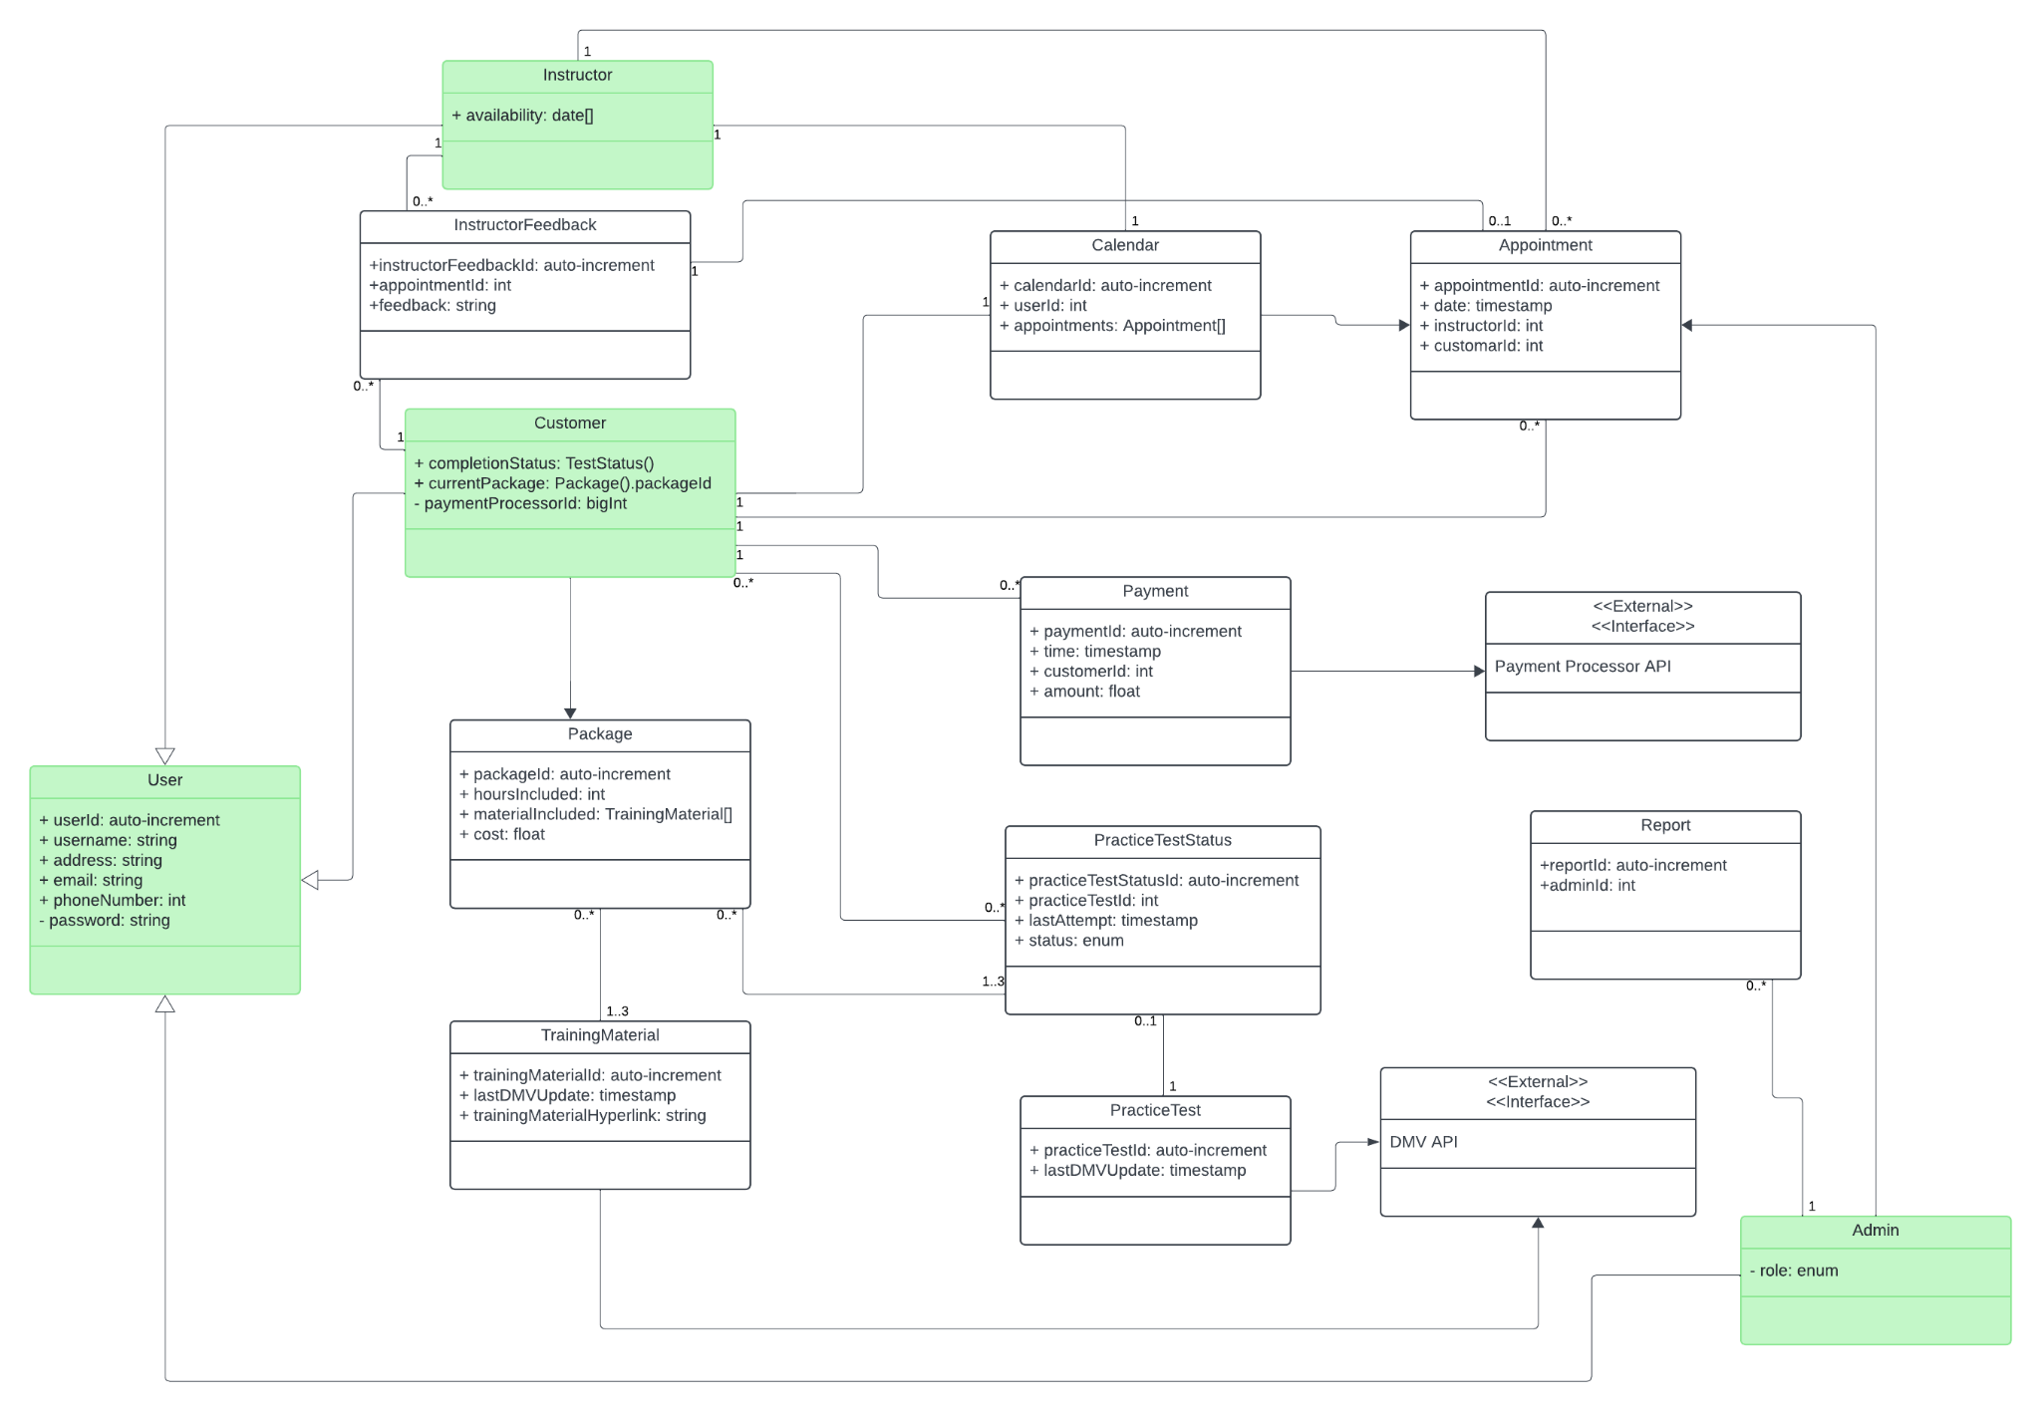

## Technical Requirements

*[Based on the diagrams you have created, describe the technical requirements of your system. These requirements should address the required hardware, software, tools, and infrastructure necessary for your system design.]*

Hardware:

- At least one local development machine for editing and testing purposes.

- A computer to access the system from for the secretary and IT personnel.

- A computer for the boss to access the system from.

Software:

- The system will be accessible through a web browser, so each machine listed above will need one installed.

- The development machine will need Javascript, Node JS, Java, Maven, and Git installed in order to replicate the development environment and to deploy updates.

Tools:

- The code base will involve utilizing a database such as MySQL in order to persist, protect, and access data.

- Git will be used to adhere to version control, ensuring updates can come from multiple developers and merge seamlessly into a single codebase.

- The system will integrate into the DMV via thei external API system. This will ensure the tests and training remain up to date.

- The system will integrate into an external payment processor, such as STRIPE, in order to fully protect customers' financial information.

Infrastructure:

- Our suggestion is a cloud host such as AWS or Microsoft Azure for the website.

- The operating system will be Linux based on these platforms, allowing for ease of scalability.

- A web based solution will allow the system to be accessible on an internet browser across platforms.